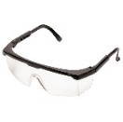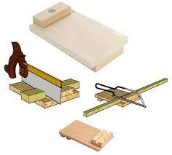******

When – Thursday 25th May 2023

Where – St. Patrick’s Primary School Hall

Time – 10am-10:30am (EVERYONE welcome!)

Children can bring some money to purchase a treat in school!

We’re raising money for

FOOTBALLS & STEM EQUIPMENT

Guess the number of cookies in the jar!!

£1 per guess



Primary 7